**Guide to Setting Up the Database in PostgreSQL**

**Objective:**The objective of this guide is to provide clear and concise instructions for setting up the **CancerClinicalTrials** database in PostgreSQL, ensuring proper database creation and configuration for managing clinical trials records.

**Step 1: Creating the database**

1. **Open pgAdmin**.
2. Type your **credentials** to connect.
3. **Right-click** on **“Local”** then **"Database"** node in the Object Explorer pane.
4. Select **“Create”** then **"Database"** from the context menu.
5. Enter the name of the database: **CancerClinicalTrials**.

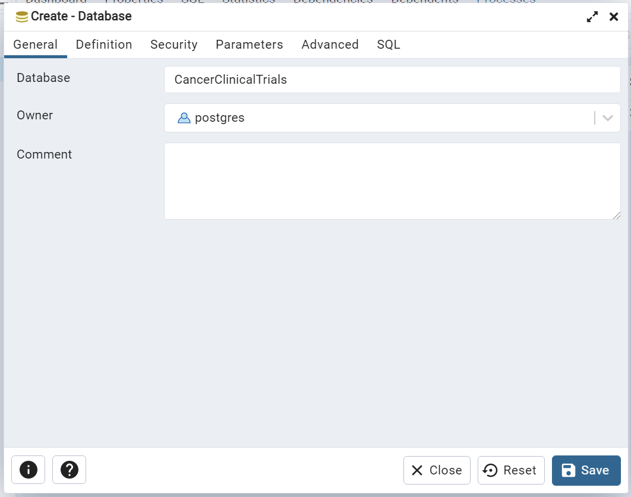

1. Click **Save** to create the database.

**Step 2: Importing tables**

1. Navigateto **CancerClinicalTrials > Schemas > Public**.
2. **Right-click** on **“Tables”** then select **"Query Tool"** in the Object Explorer pane.
3. Copy and paste the sql content from **CancerClinicalTrials.sql** locatedin **docs** folder.